Information Retrieval (CS60092)
Computer Science and Engineering, Indian Institute of Technology Kharagpur

Mid Semester Examination

Time: 2 hours

Answer as much as you can.
Use of calculator is allowed.

Q. 1> Consider an inverted index over a corpus of 50,000 documents. Let the sequence (3, 5, 1200, 1600, 1843, 4235) be the postings list of a certain term in the inverted index. Compute the size of this postings list if the postings list is stored as a sequence of gaps and the numbers are encoded using

- Unary
- Fixed-length binary
- Gamma
[2+2+6]

Answer:
The size of the postings list is the sum of the sizes of the encodings of the gaps 3, 2, 1195, 400, 243, 2392.

Unary: 4+3+1196+401+244+2393 = 4241 bits = 531 bytes (approx)
Fixed length binary: 6 X 16 = 96 bits = 12 bytes
Gamma: 3+3+21+17+15+23 = 82 bits = 11 bytes (approx)

Q. 2> Consider the following postings lists p1 and p2. p1 has skip pointers. p2 does not have any skip pointer.

p1: 3 5 9 15 24 39 60 68 75 81 84 89 92 96 97 100 115
p2: 3 5 89 95 97 99 100 101
- Intersect the postings lists WITHOUT USING the skip pointers. Write down the comparisons (x,y) made while doing the intersection, where x is a docID from p1 and y is a docID from p2.
How many comparisons are required?

Answer:
The comparisons are: (3,3), (5,5), (9,89), (15,89), (24,89), (39,89), (60,89), (68,89), (75,89), (81,89), (84,89), (89,89), (92,95), (96,95), (96,97), (97,97), (100,99), (100,100), (115,101).
19 comparisons are required.
- Intersect the postings lists USING the skip pointers. Write down the comparisons (x,y) made while doing the intersection, where x is a docID from p1 and y is a docID from p2.
How many comparisons are required?

Answer:
The comparisons are: (3,3), (5,5), (9,89), (15,89), (24,89), (75,89), (92,89), (81,89), (84,89), (89,89), (92,95), (115,95), (96,95), (96,97), (97,97), (100,99), (100,100), (115,101).
18 comparisons are required.

- Do skip pointers help in processing AND queries? Justify your answer.

Answer:
Yes. AND queries are of the form “t1 AND t2”. In the postings list for t1, let DocIDs of the current pointer and the skip target be x1 and x2 respectively. In the postings list for t2, suppose the current pointer is at docID y1. As the entries in a postings list are stored in increasing order of docIDs, if both x1 and x2 are less than y1, then the current pointer of the postings list of t1 can be advanced to x2. None of the documents having ids between x1 and x2 can be an answer to the AND query, as they do not contain the term t2. Thus having skip pointers can reduce the number of docID comparisons while processing AND queries.

- Do skip pointers help in processing OR queries? Justify your answer.

Answer:
No. While processing queries of the form “t1 OR t2”, it is essential to visit every docID in the posting lists of both the terms. Thus skipping part of either list will result in incorrect answer.
[4+4+1.5+1.5]
Q. 3> a) Let the relevance labels of the first 10 documents for a query be 1, 0, 0, 1, 1, 0, 1, 0, 0, 0. Here, 1 means relevant and 0 means non-relevant. Suppose total number of relevant documents for this query is 5.
- Draw the Precision-Recall curve for this result set.
- Write down the general formula for finding the interpolated precision value at recall level ‘r’.
- Draw the interpolated precision curve.
- What is the average precision for this result set?

Answer:
- And (iii):
Position | 1 | 2 | 3 | 4 | 5 | 6 | 7 | 8 | 9 | 10
Relevant | 1 | 0 | 0 | 1 | 1 | 0 | 1 | 0 | 0 | 0
Precision | 1 | 1/2 = 0.5 | 1/3 = 0.33 | 2/4 = 0.5 | 3/5 = 0.6 | 3/6 = 0.5 | 4/7 = 0.57 | 4/8 = 0.5 | 4/9 = 0.44 | 4/10 = 0.4
Recall | 1/5 = 0.2 | 1/5 = 0.2 | 1/5 = 0.2 | 2/5 = 0.4 | 3/5 = 0.6 | 3/5 = 0.6 | 4/5 = 0.8 | 4/5 = 0.8 | 4/5 = 0.8 | 4/5 = 0.8

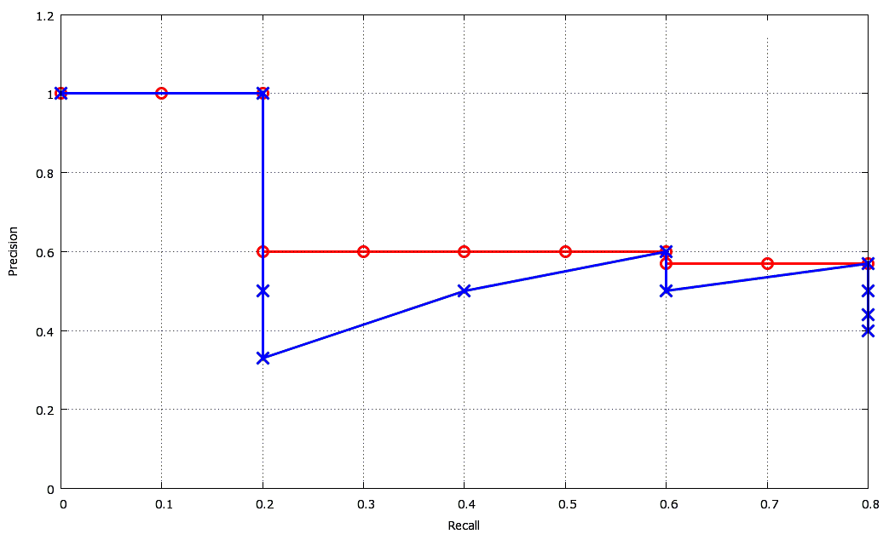
The blue curve is the Precision vs Recall curve.
The red curve represents the Interpolated Precision curve.
(ii)
P_interpolated(r) = max_{r’ >= r} p(r’)
Where, P_interpolated(r) is the interpolated precision at recall level r.
P(r) is the precision at recall level (r).
(iv)
Average Precision = 1/5 * (1 + 0.5 + 0.6 + 0.57) = 0.734
b) Suppose a user has three different types of information needs and enters queries accordingly. Which one among the three evaluation measures Precision, Recall and Reciprocal Rank should be used to measure the effectiveness of the result sets for each of the following query types?
- Website of IIT Kharagpur
- Searching for free high quality wallpapers
- Information about Cardiovascular Disease
- Looking at research done in a particular area before preparing a research proposal

Answer:
- Reciprocal Rank. The user is most likely to follow the first result that points to the website.
- Precision. The user will look for some good websites from which wallpapers may be downloaded. However, he will not need all the websites that offer free wallpapers. So he might not be interested in going beyond first or second page of the result set.
- Precision. Unless done for research purpose, the user will most likely be interested in finding some basic information like reasons, medication and expert advice regarding the disease. So he/she will probably look at the first few results, and hope that those pages are informative.
- Recall. The user will need to be aware of all the work that has been done in this area so as to avoid any duplication in research.
[(3+3+2+1.5) + (4 x 1)]
Q.4> Consider the following graph, which shows webpages and their link structure. There are three domains in this graph: A, B and C. A has one webpage, B has two webpages B1 and B2, C has three webpages C1, C2 and C3.
C2
C3
B2

B1
C1

A

Suppose a crawler takes 100 milliseconds to fetch one webpage. Politeness Policy states that, a crawler cannot issue more than one page request to any domain in 50 milliseconds. This means that to crawl two pages in same domain, 50 milliseconds must have elapsed between the end of crawl on one webpage and beginning of crawl on another.
Give numerical answers with proper explanations to the following two questions
- Crawler X must crawl in the following manner: Once the crawler fetches a page in a domain, the crawler must finish crawling all pages within that domain before switching to a different domain. What is the shortest time in which X can finish crawling all pages if it observes the Politeness Policy and starts crawling on page A?
- Crawler Y must crawl in the following manner: It can crawl any webpage that is linked to it by a webpage that has already been crawled. What is the shortest time in which Y can finish crawling all pages if it also observes the Politeness Policy and starts crawling on page A?
[6+6]
Answer:
- X must finish crawling all pages within one domain before switching to a different domain. So, no matter whether it starts crawling domain B or domain C after finishing domain A, the time required will be the same.
Total time required = 100 + (100+50+100) + (100+50+100+50+100) milliseconds
= 750 milliseconds
- Y can crawl any webpage that is linked to it by a webpage that has already been crawled.
Here the crawling order would be: A->C1->B1->C2->B2->C3
Total time required = 6*100 milliseconds
= 600 milliseconds
Q.5> Suppose that a document collection consists of following two documents
d1: free eBooks free software eBooks
d2: hundred free pdfs
User’s initial query is
q: free eBooks free pdfs free computer eBooks
The user judges d1 relevant and d2 non-relevant. Assume that we are using direct term frequency (with no scaling and no document frequency). There is no need to length-normalize vectors.
Using Rocchio relevance feedback, what would the revised query vector be after relevance feedback?
Assume α = 1, β = 0.75, γ = 0.25.
[6]
Answer:
The formula for Rocchio Algorithm is
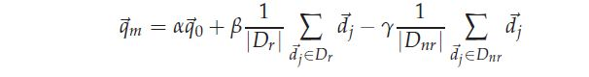
Where q_{m} is the modified query, q₀ is the original query vector, D_{r} and D_{nr} are the set of known relevant and non-relevant documents respectively, and α, β, and γ are weights attached to each term.
Here number of relevant and non-relevant documents are both 1.
So, the modified query would be
1*(3 * free +2* eBooks +pdfs +computer) + 0.75*(2* free+ 2*eBooks+ software) - 0.25*(hundred+ free+ pdfs)
= (3+0.75*2-0.25) * free+ (2+0.75*2) *eBooks+ computer+ (1-0.25)*pdfs+0.75*software
= 4.25* free +3.5* eBooks+ computer+ 0.75*pdfs+ 0.75*software

Q.6> Draw the DOM tree for the following XML document:

<db>
<customer>
<name>
<firstname>John</firstname> <lastname>Doe</lastname>
</name>
<phone>
<areacode>512</areacode> <number>471-9558</number>
</phone>
<purchases>
<item>
<camera>
<type>Canon digital</type> <price>200</price>
</camera>
</item>
</purchases>
</customer>
</db>
[4]
Answer:
root element
db

element
customer
element
purchases
element
phone

element
name
element
areacode
element
number
element
item
element
lastname
element
firstname
text
John
text
Doe
text
512
text
471-9558
element
camera
element
type
element
price
text
Canon digital
text
200

